React Basic Hello Word program
- Dw & install node version any(latest pref)
node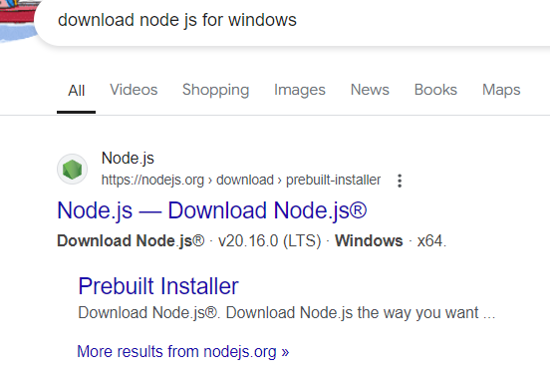
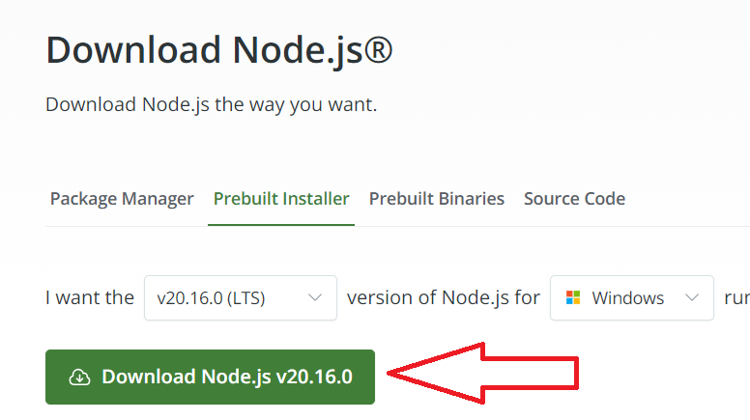

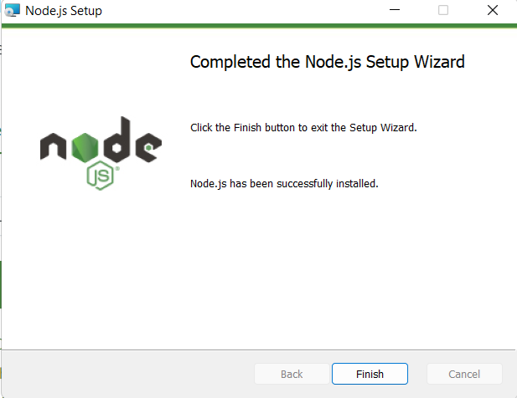

To verify open command line
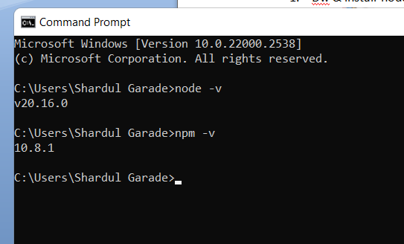

Run following command on powershell
Set-ExecutionPolicy RemoteSigned -Scope CurrentUser

Make a folder(react-applications) // use any name

Open the react-applications folder in vscode

Open terminal

cd react-applications //make sure the location is showing on the prompt
D:\ react-applications >

D:\ react-applications > npm create vite@latest

Give the project name “first-react-project”
Choose React
Choose JavaScript

D:\ react-applications > cd first-react-project
D:\ react-applications\first-react-project > npm i
D:\ react-applications\first-react-project > npm run dev

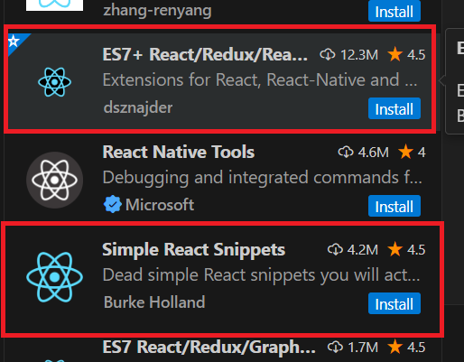
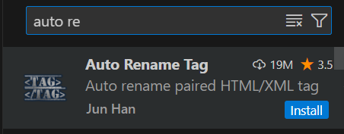
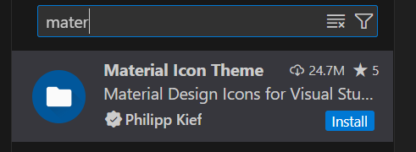

Clear the app.css
Clear the index.css
Clear the app.jsx

Install the ES7+React/Redux vendor dsnnajder

In App.jsx write rafce select
import React from 'react'

const App = () => {
return (
<div>Welcome to React JS</div>
)
}

export default App

